**Solana New Token:**

* Solana-keygen grind –starts-with bos:1 (to set the boss of the mint authority)
* it generates the address that starts with bos
* 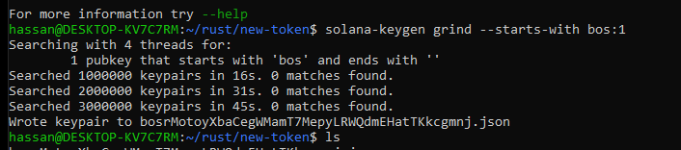
* Solana config set –keypair boss(publickey).json (to set the boss to the Solana to use)
* 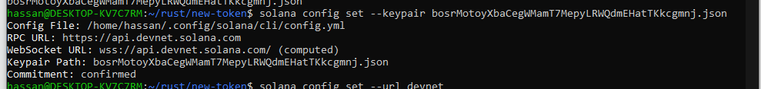
* Solana config set –url devnet (to set the network to the dev)
* 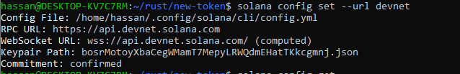
* Solana config get (to check the details)
* 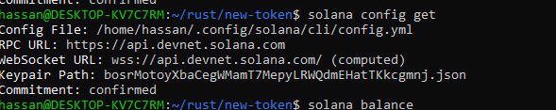
* Must have balance in your account or get from solana.faucet.com
* 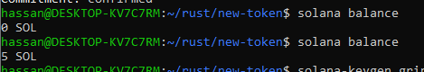
* Solana-keygen grind –starts-with mnt:1 (Set the unique address to remember or identify)
* It will create the address that starts with the mnt just like the bos
* 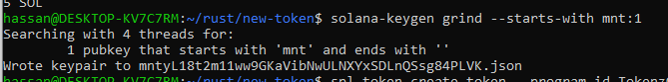
* That will be the address where we put our token mint
* Now to create new token
* Spl-token create-token –program-id TokenzQdBNbLqP5VEhdkAS6EPFLC1PHnBqCXEpPxuEb –enable-metadata mntyL18t2m11ww9GKaVibNwULNXYxSDLnQSsg84PLVK.json
* 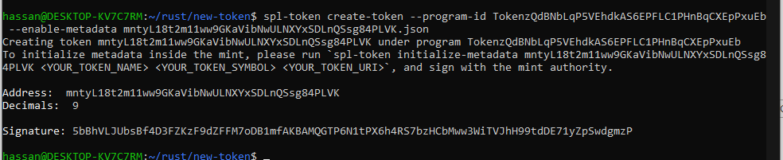
* You can check the token on the explorer.solana.com
* 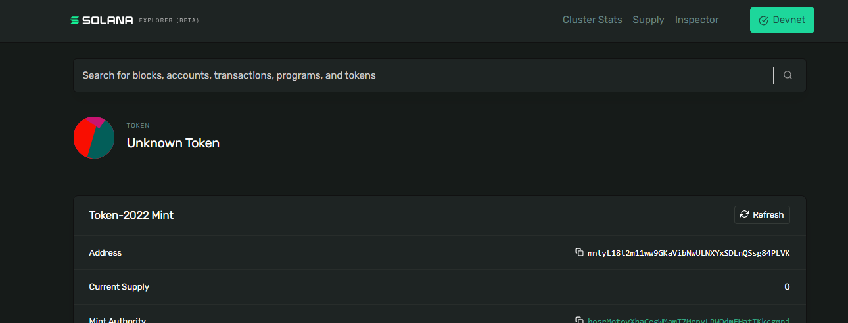
* Now for the metadata we need to upload the JSON file and the image for the token somewhere publicly on the internet like on GitHub etc.
* For the mainnet we use decentralized services like IRIS to upload the data but for the net purpose we are using GitHub